Day21 - Task09 - AWS VPC

Create VPC with 2 private and 2 public subnets.
Description
Create a custom network with four subnets (2 public, 2 private).
AWS Console Actions
VPC → Create VPC → Create 4 subnets in different Availability Zones.
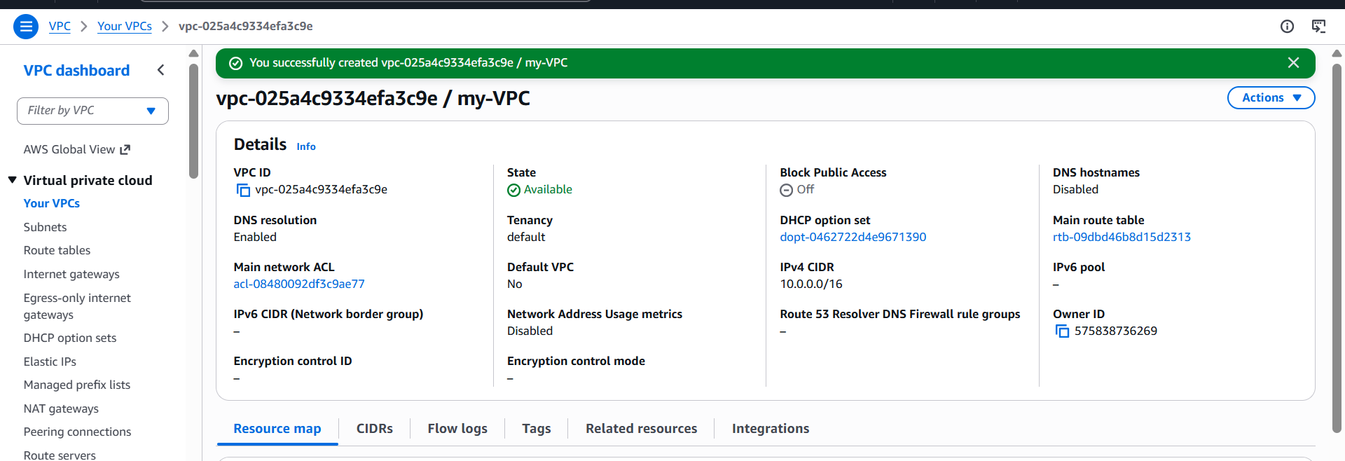

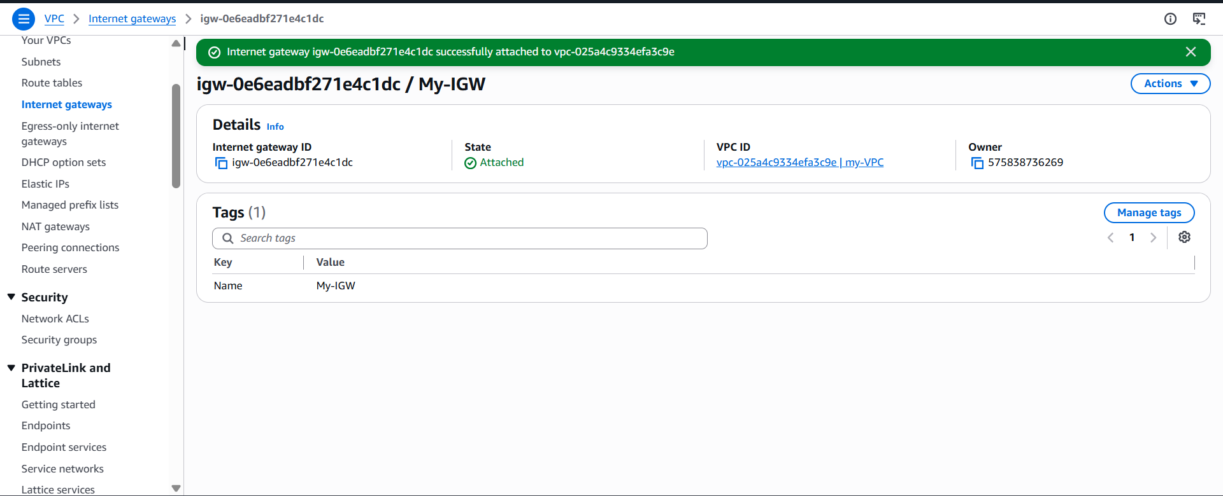
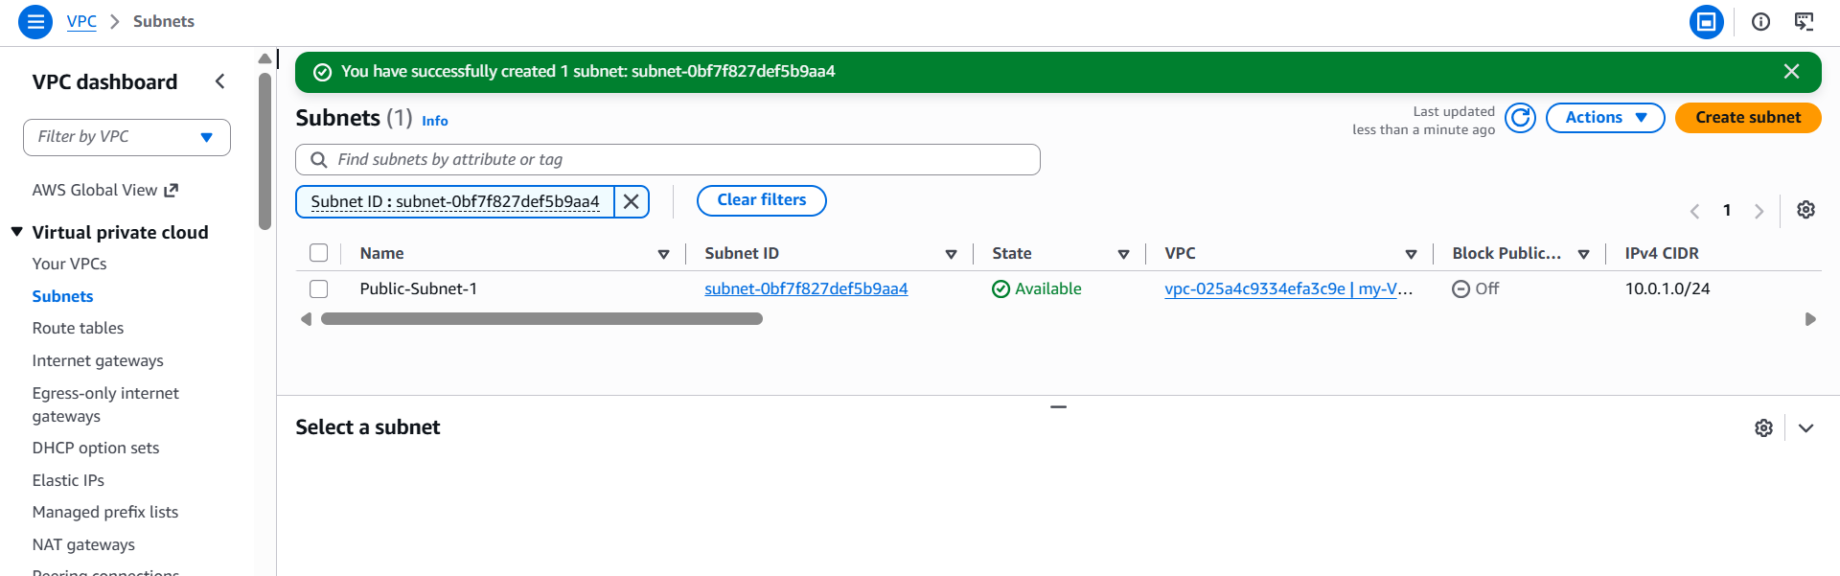
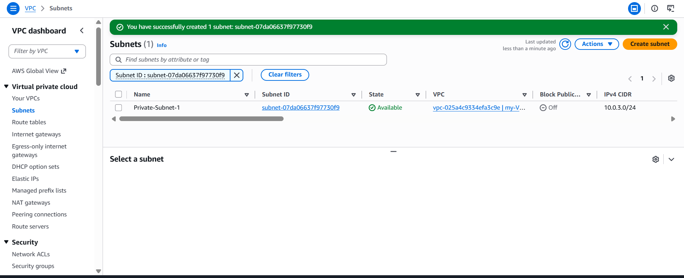
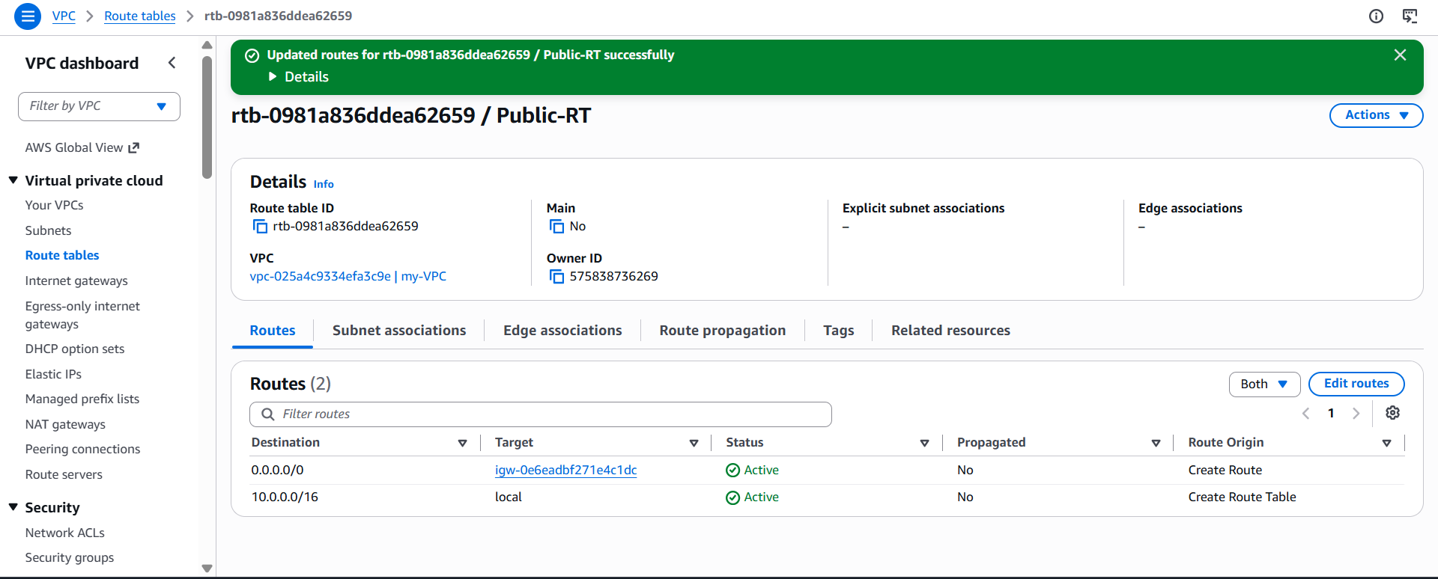
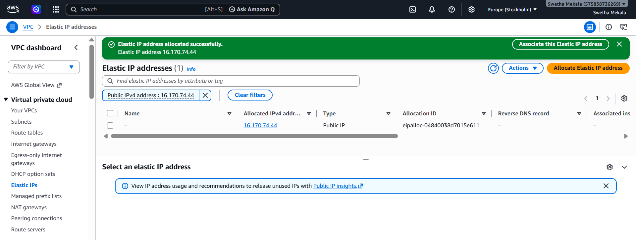
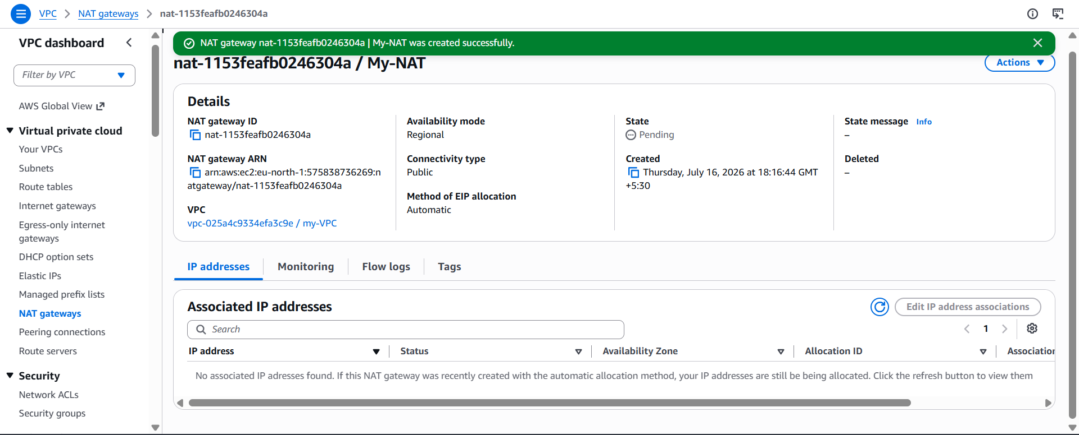
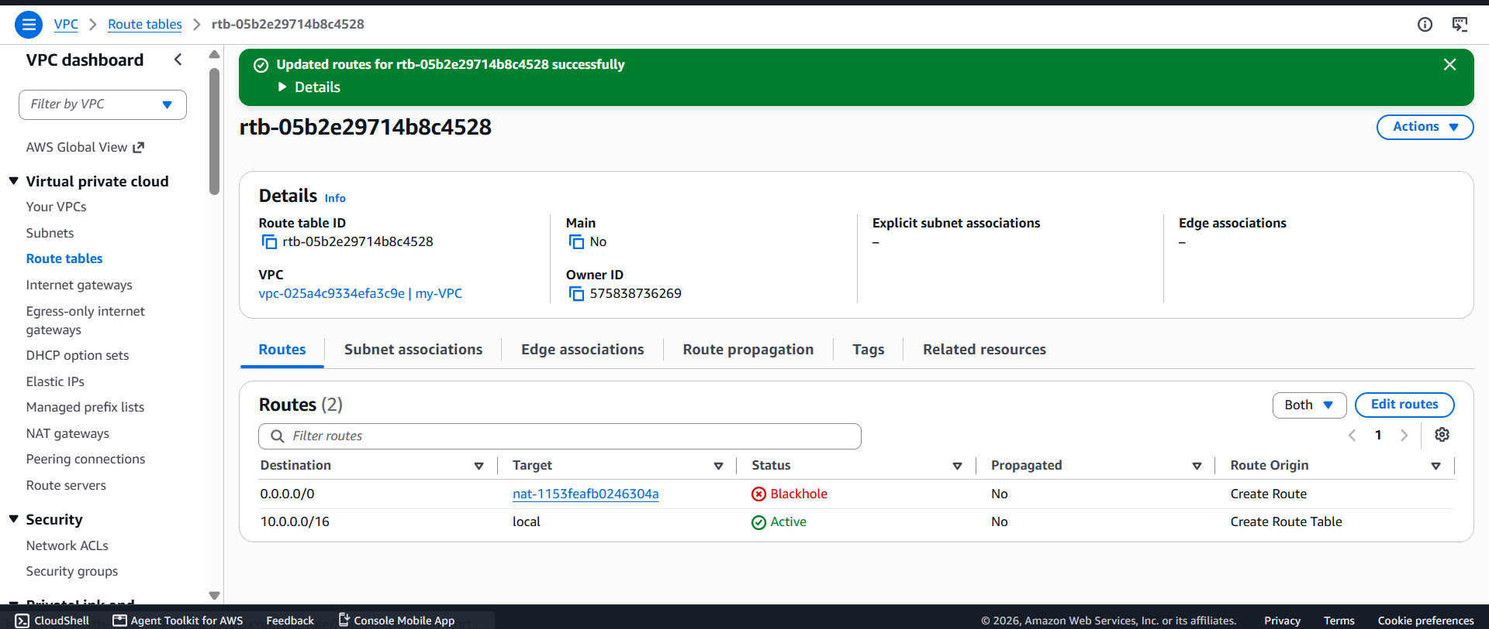
Enable DNS Hostname in VPC.
Description
Allows EC2 instances to receive DNS hostnames.
AWS Console Actions
VPC → Your VPCs → Select VPC → Edit VPC Settings → Enable DNS Hostnames.
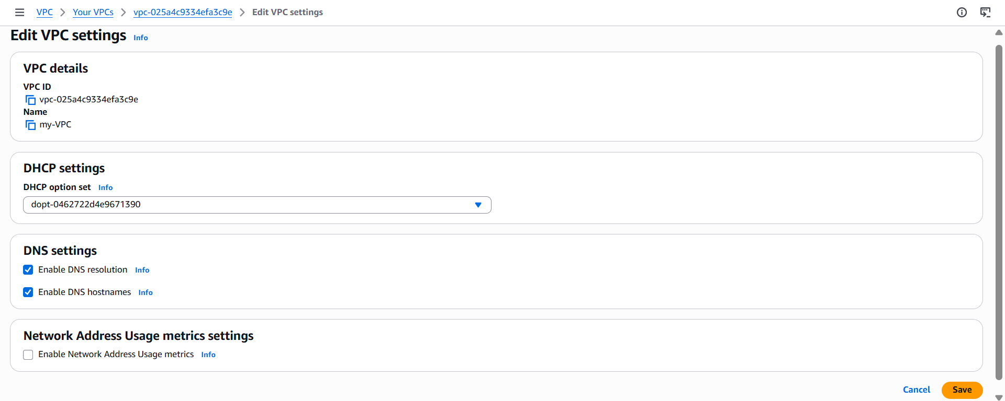Enable Auto Assign Public IP in 2 public subnets.
Description
EC2 instances launched in public subnets automatically receive public IPs.
AWS Console Actions
Subnets → Select Public Subnet → Actions → Edit subnet settings → Enable Auto-assign public IPv4
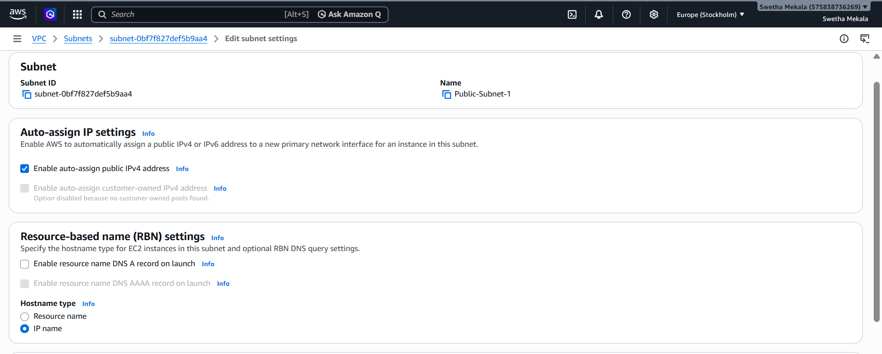

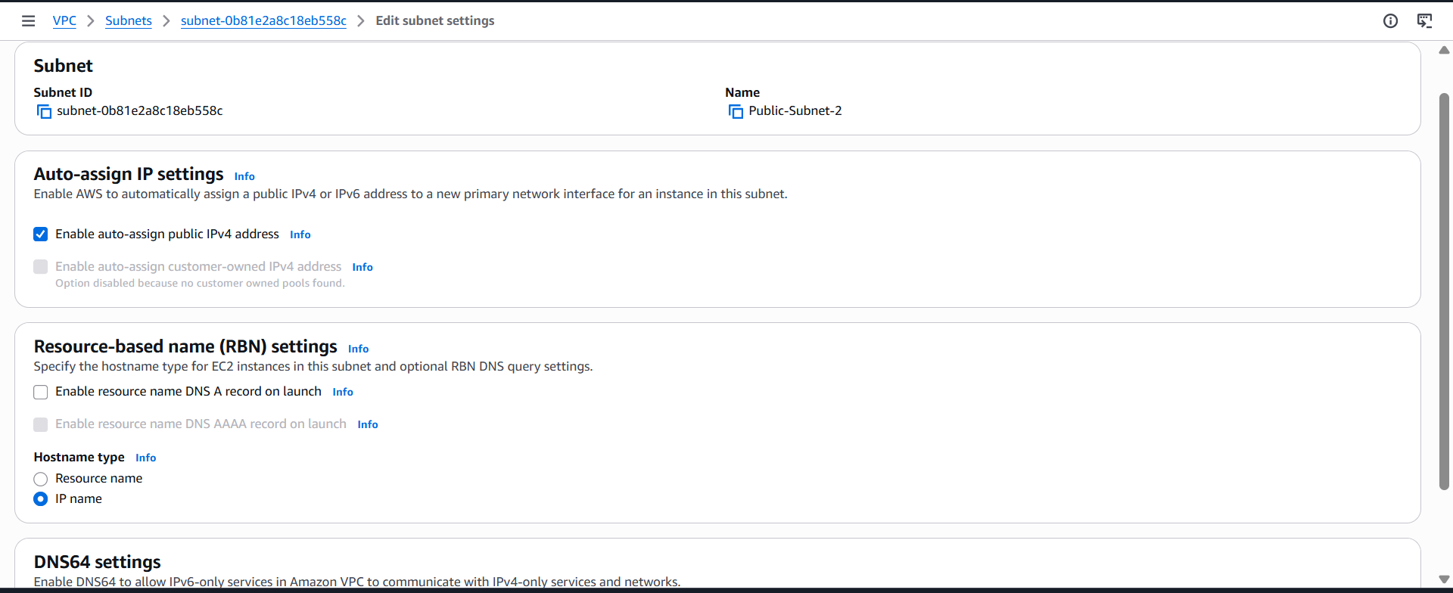

Add 2 private subnets in private route table.
Description
Associate the two private subnets with the private route table.
AWS Console Actions
Route Tables → Select Private RT → Subnet Associations → Edit Associations.
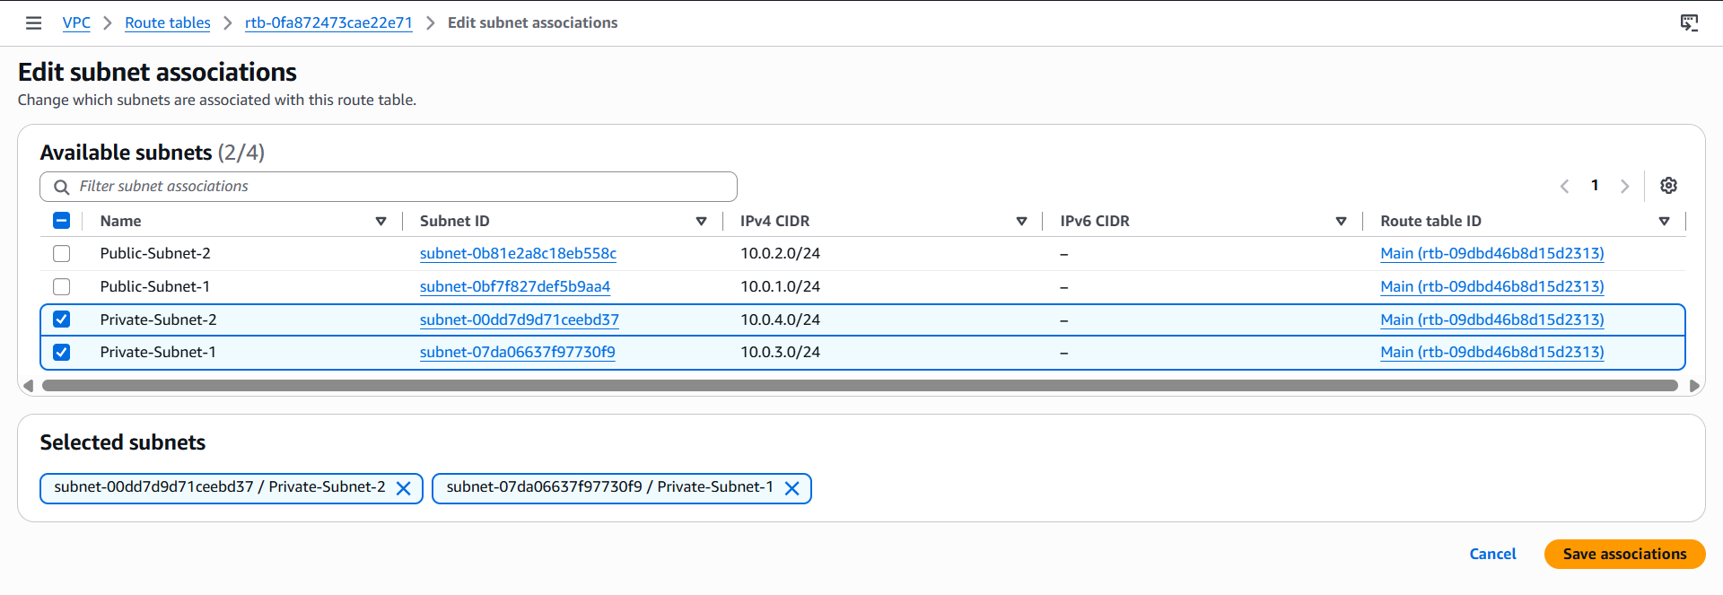
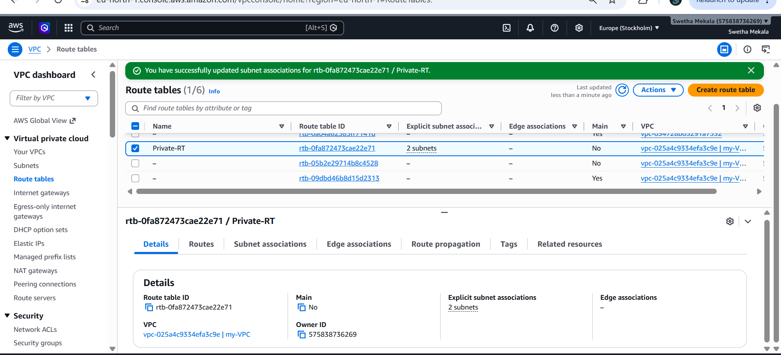
Add 2 public subnets in public route table.
Description
Associate the public subnets with the public route table.
AWS Console Actions
Route Tables → Select Public RT → Subnet Associations → Edit Associations.
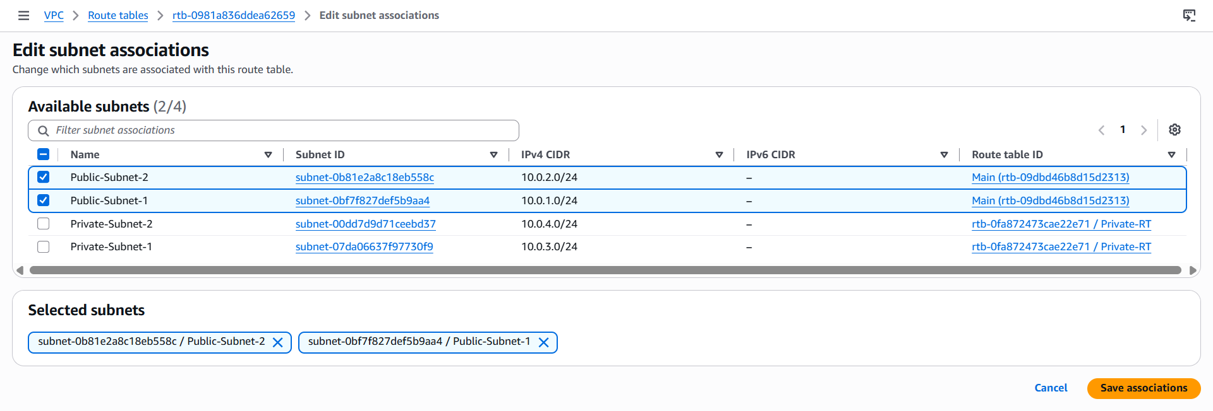
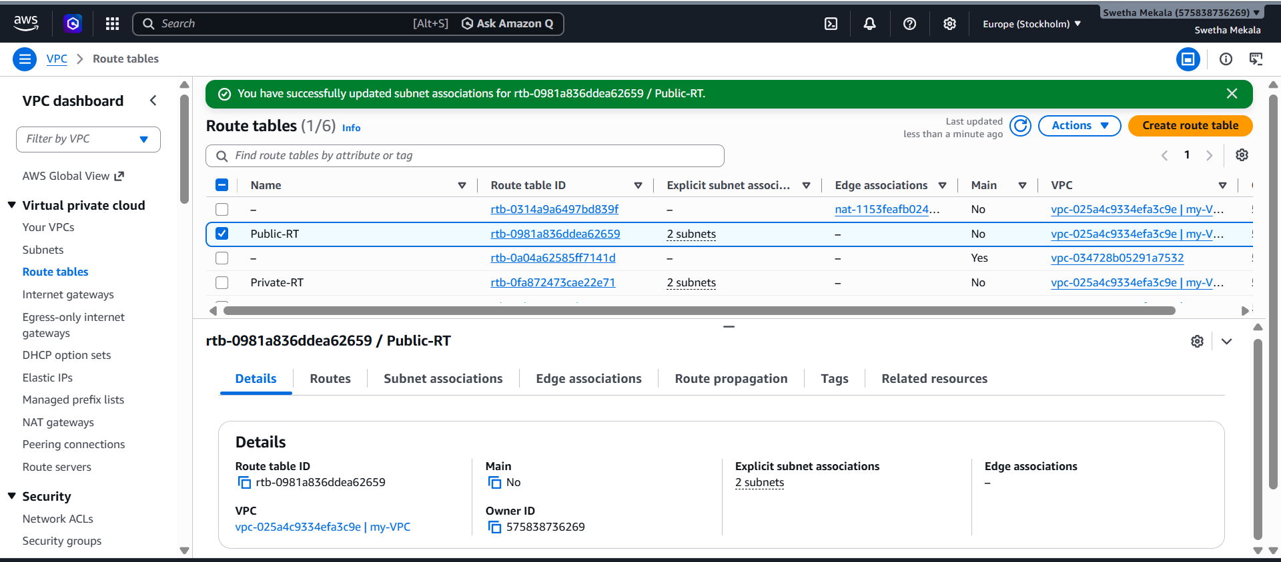
Public route table will have the routes to internet and local.
Description
Configure internet access for public subnets.
AWS Console Actions
Add routes: Local (automatic) and 0.0.0.0/0 → Internet Gateway (IGW).
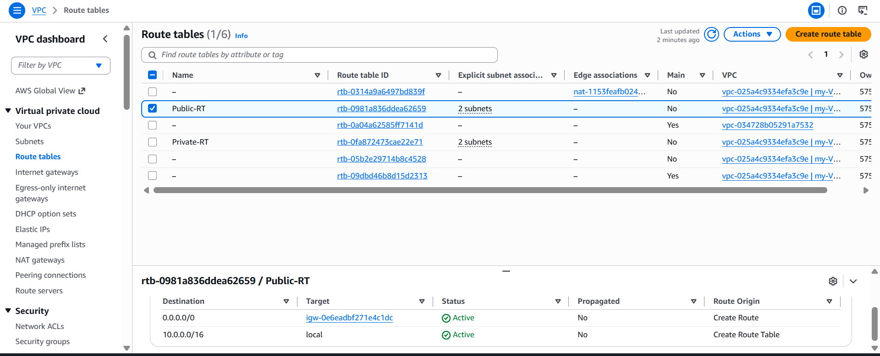
Create EC2 in public subnet with t2.micro and install PHP.
Description
Launch an EC2 instance in a public subnet and install PHP.
AWS Console Actions
EC2 → Launch Instance → Choose t2.micro → Public subnet → Security Group → Allow SSH (22) and HTTP (80).

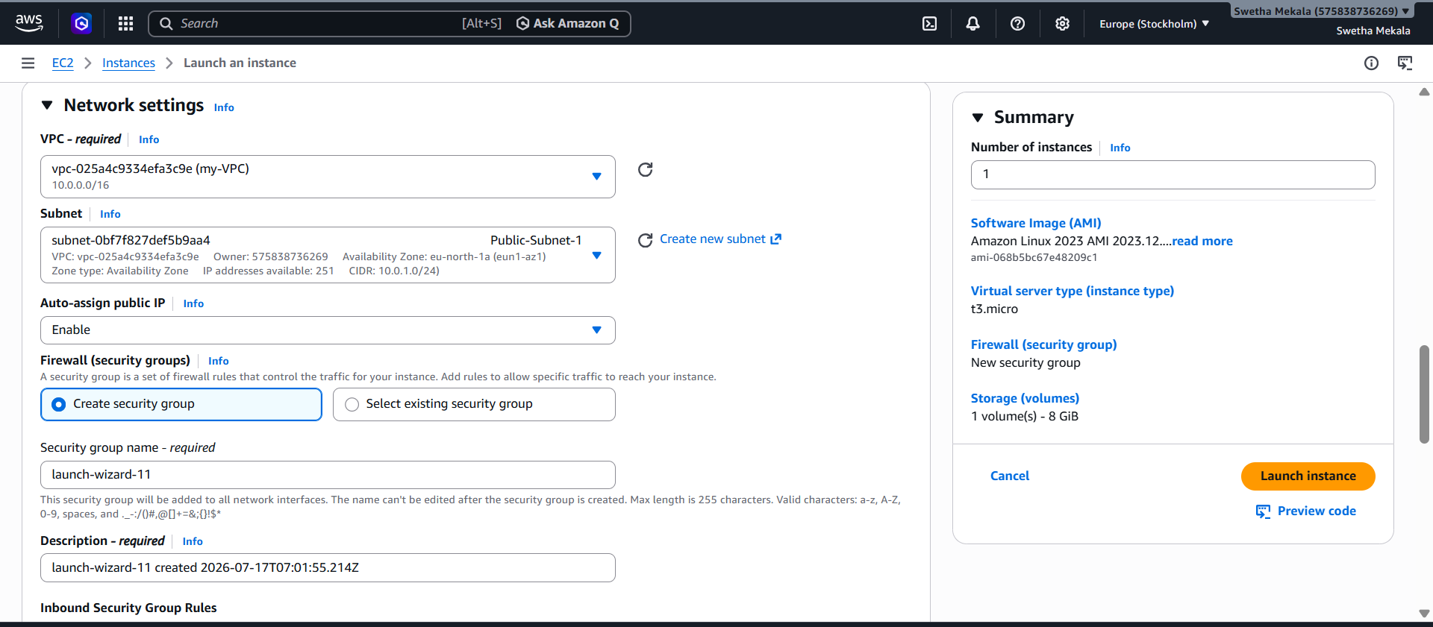
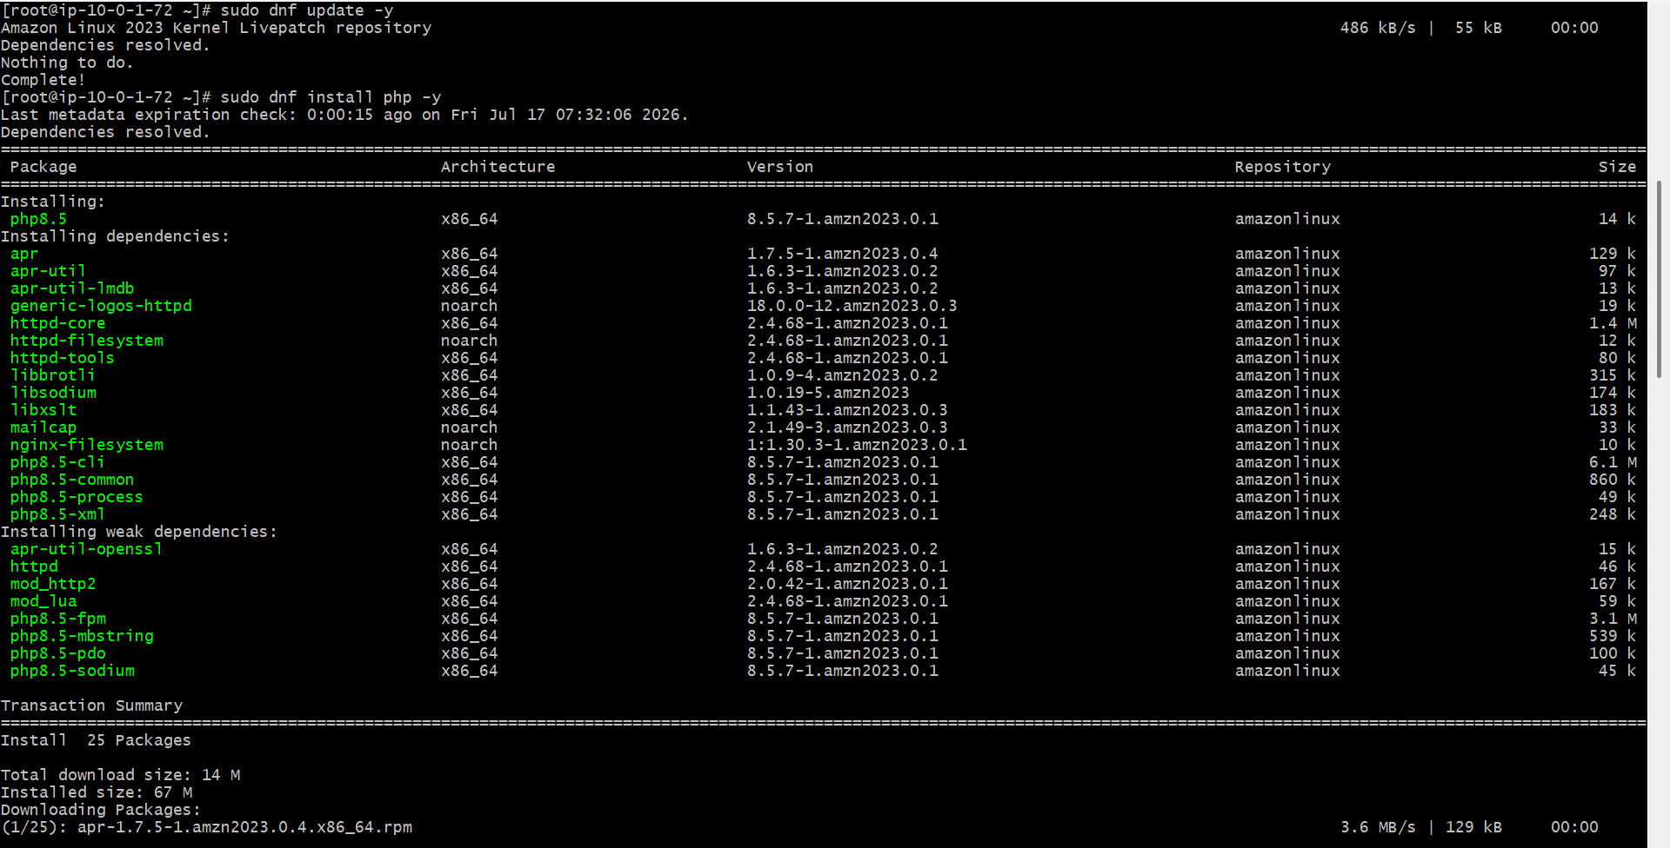
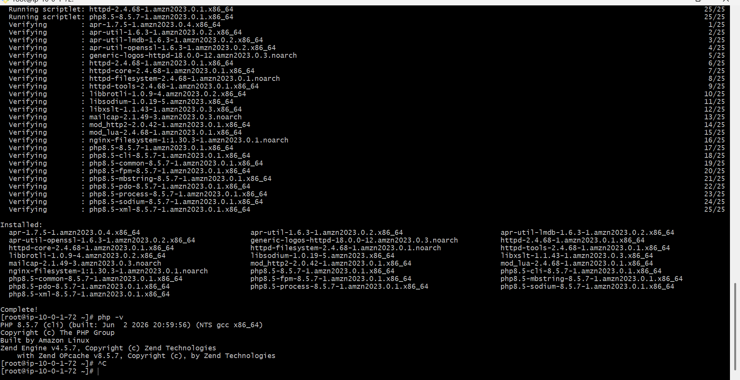
Configure NAT gateway in public subnet and connect to private instance.
Description
Create a NAT Gateway so private instances can access the internet for updates.
AWS Console Actions
Create Elastic IP → NAT Gateway → Public subnet → Update Private Route Table → 0.0.0.0/0 → NAT Gateway.
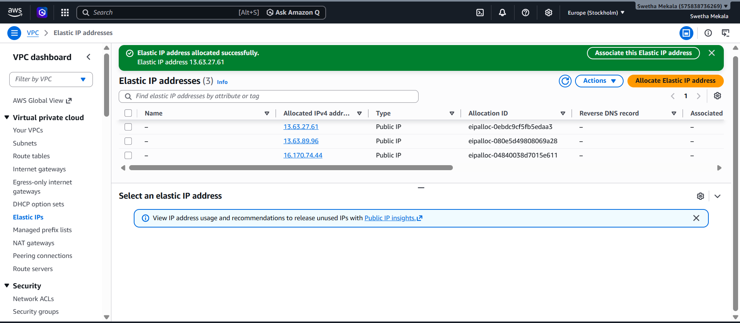
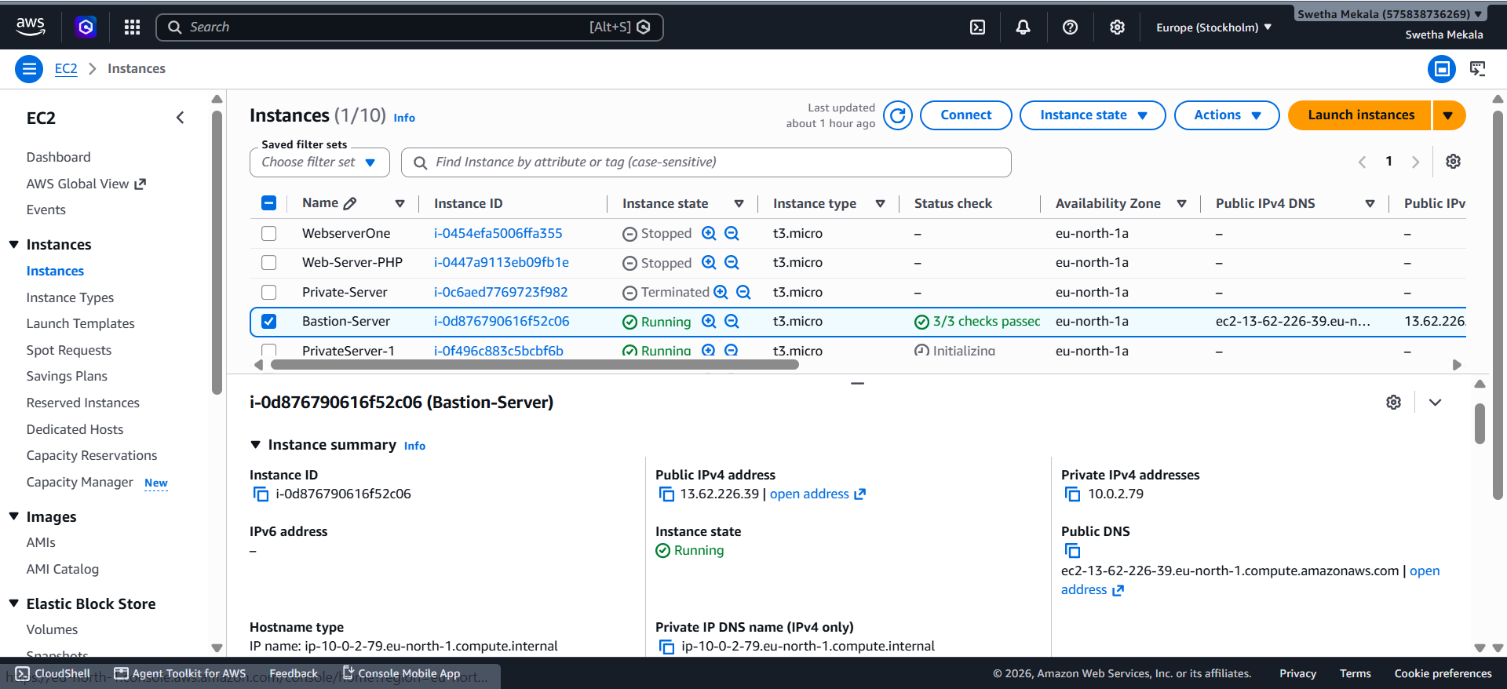

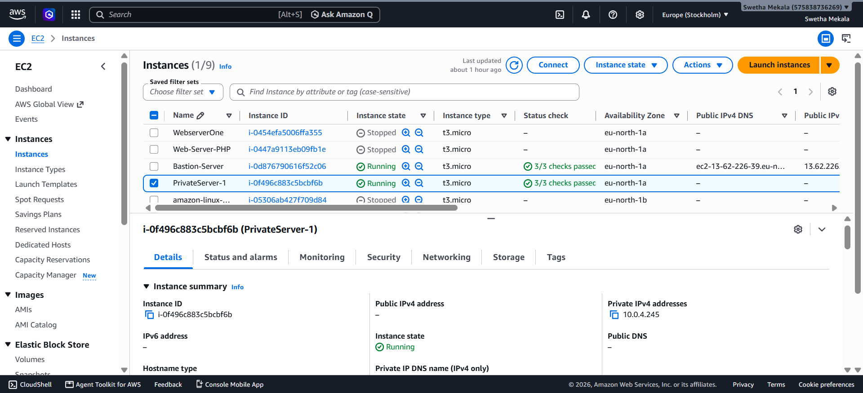

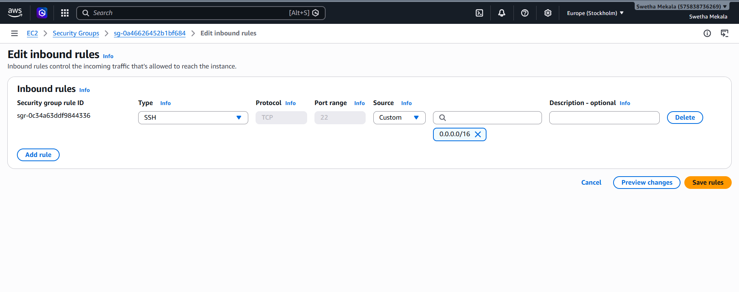
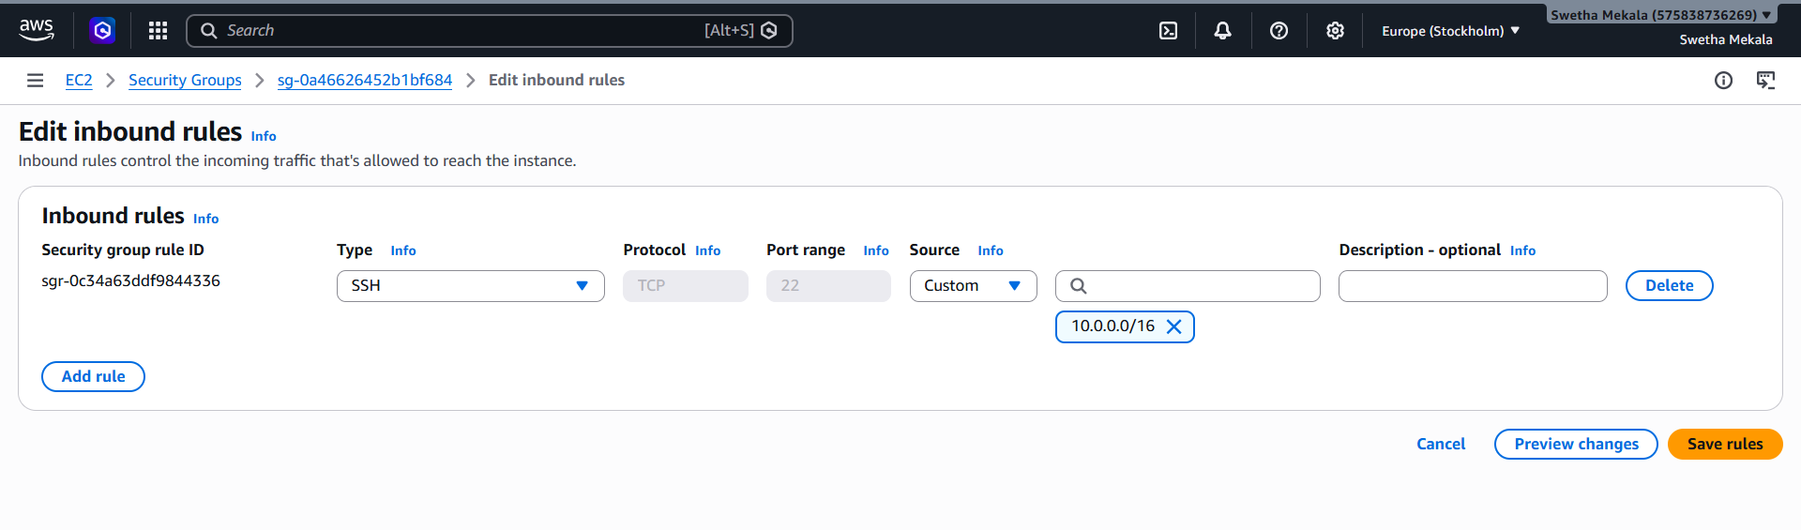
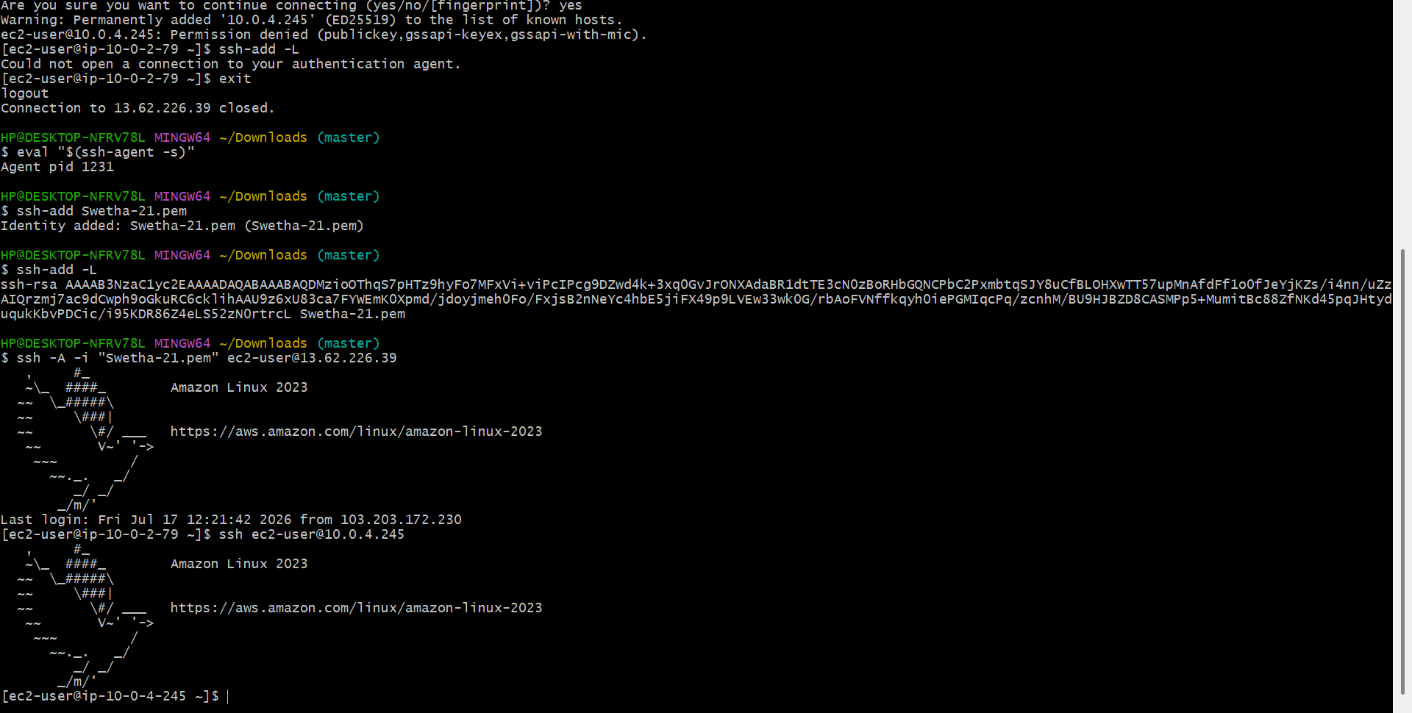
Install Apache Tomcat in private EC2 and deploy a sample app.
Description
Install Java and Tomcat, then deploy a sample WAR application.
AWS Console Actions
Launch EC2 in private subnet → Connect using Bastion Host or Session Manager.
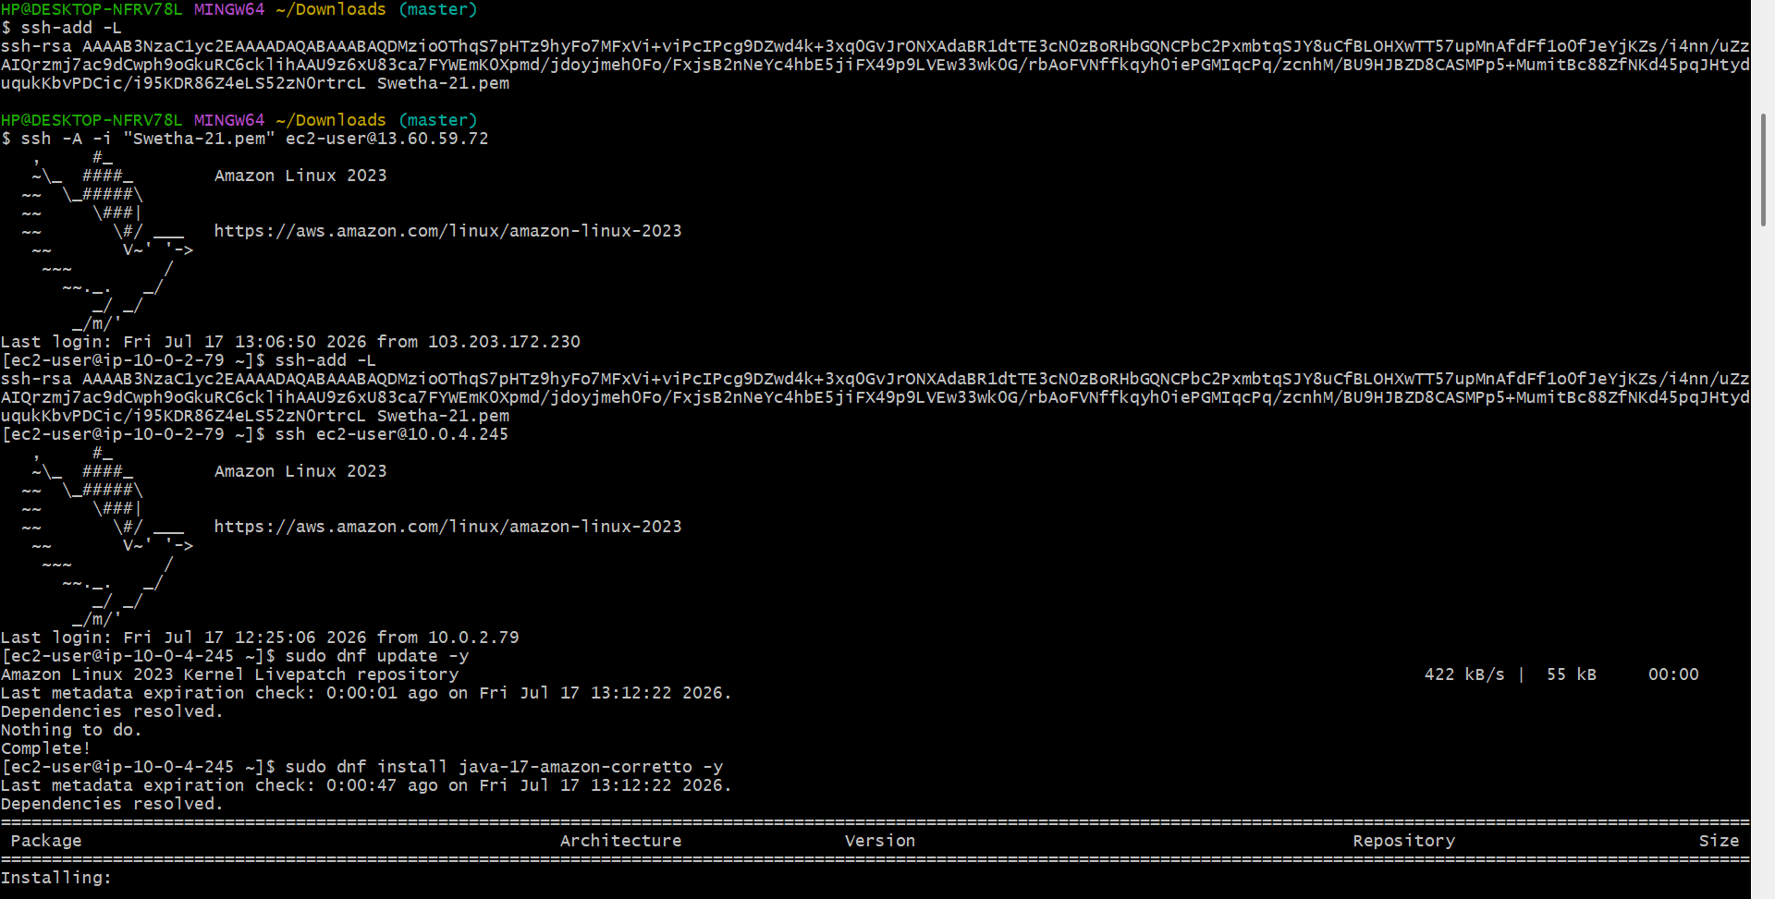

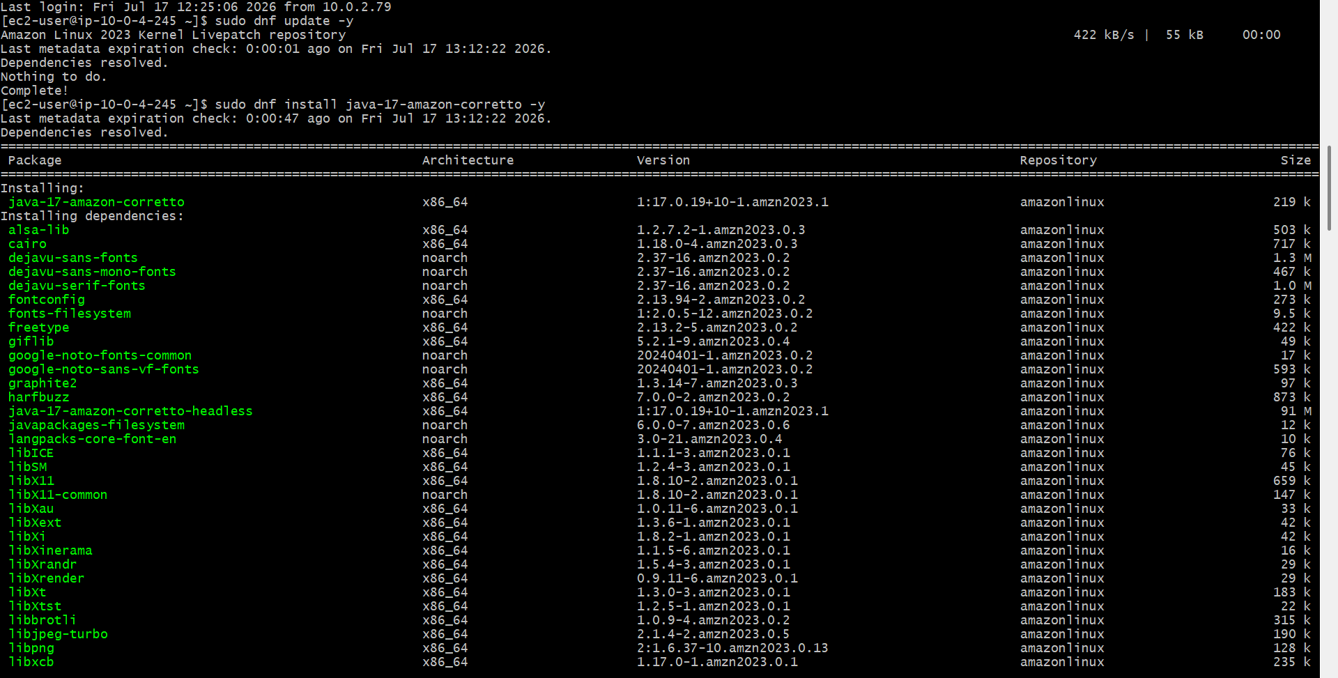
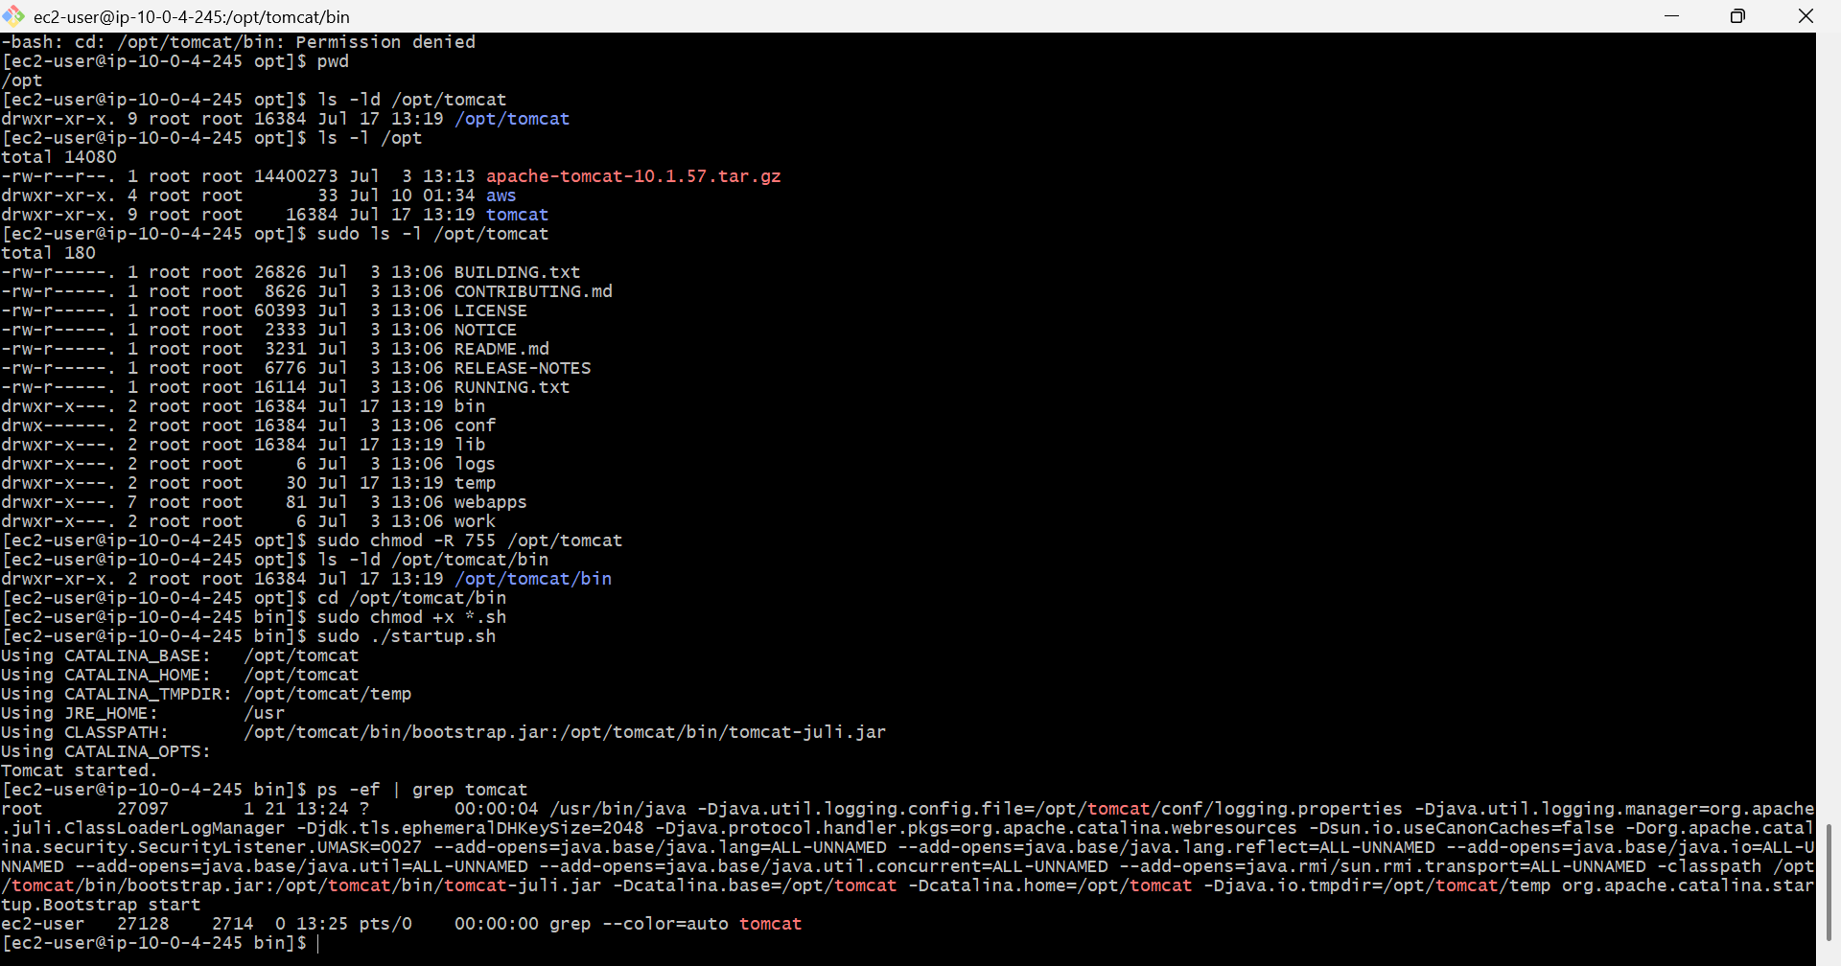
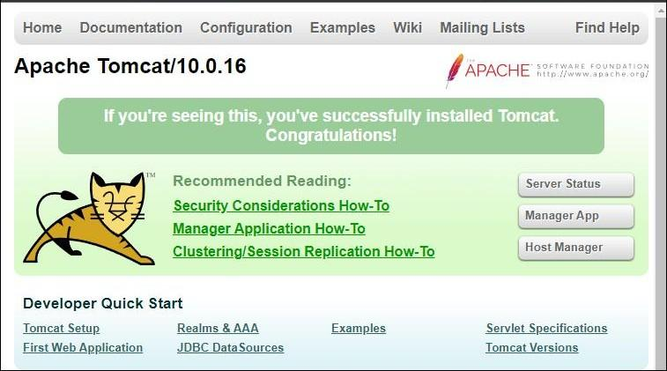
Configure VPC flow logs and store the logs in S3 and CloudWatch.
Description
Amazon VPC Flow Logs is an AWS feature that captures information about the IP traffic flowing through network interfaces in a VPC. These logs help monitor network traffic, troubleshoot connectivity issues, analyze security events, and audit network access.
In this task, a VPC named myVPC was used. A Flow Log was created for the VPC with the filter set to All, so that both accepted and rejected network traffic would be captured.
CloudWatch Logs Destination
- A CloudWatch Log Group named VPCFlowLogs was created.
- An IAM service role was automatically created to allow the VPC Flow Logs service to publish logs to CloudWatch.
- After generating network traffic from an EC2 instance by running ping google.com, the flow log records appeared in the CloudWatch Log Group.
Amazon S3 Destination
- An S3 bucket named my-vpc-flowlogs-2026 was created.
- A second Flow Log was configured with the destination set to Amazon S3.
- After generating network traffic, compressed .log.gz files containing the VPC Flow Logs were successfully stored in the S3 bucket under the AWSLogs directory.

AWS Services Used
- Amazon VPC
- Amazon EC2
- Amazon CloudWatch Logs
- Amazon S3
- AWS IAM

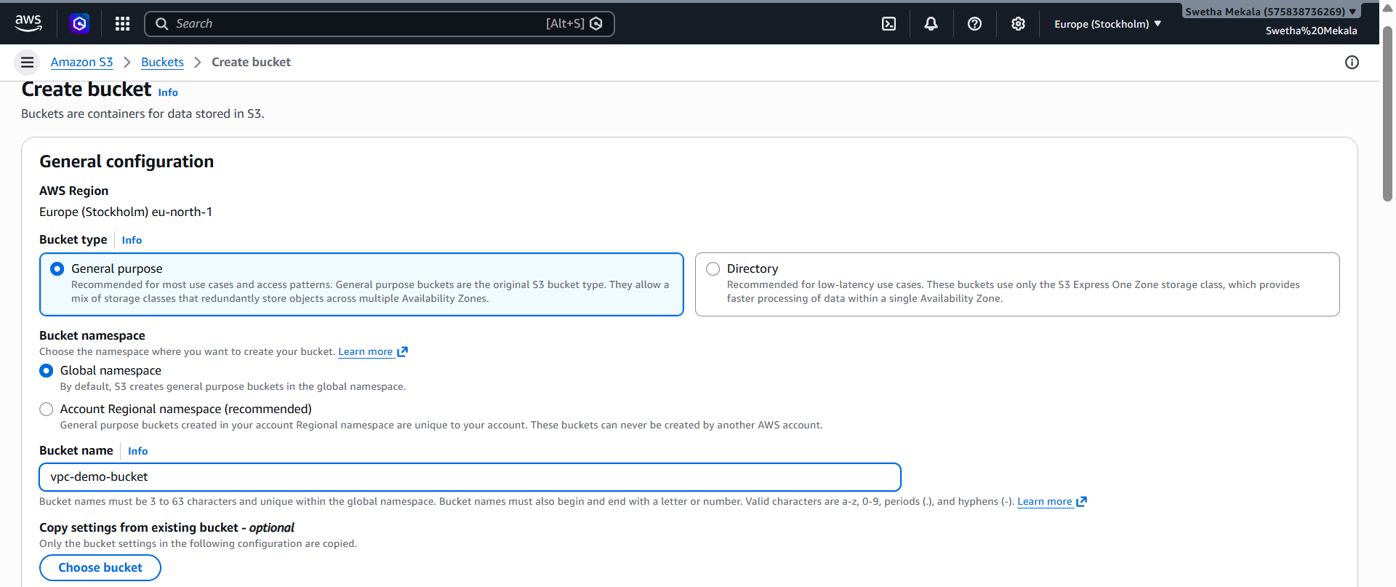
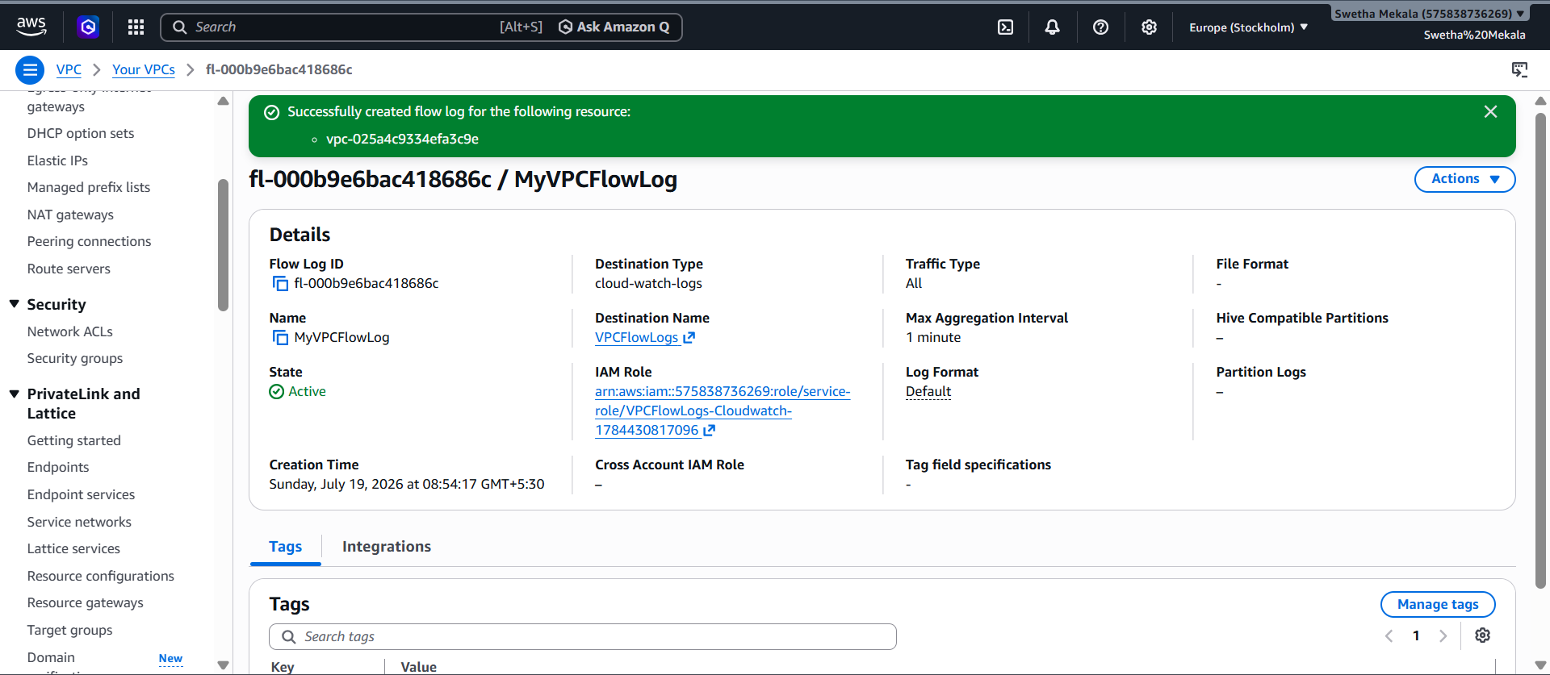
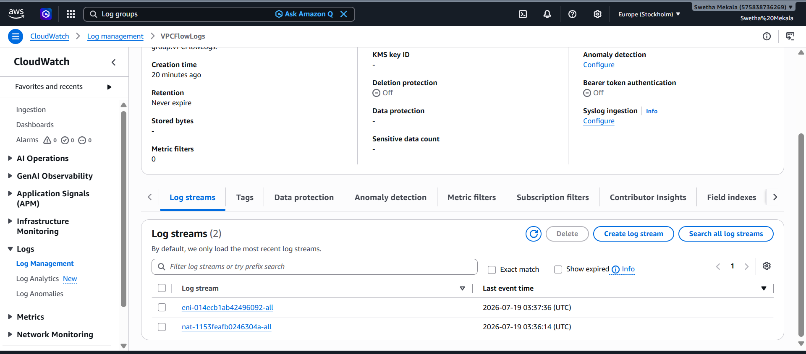
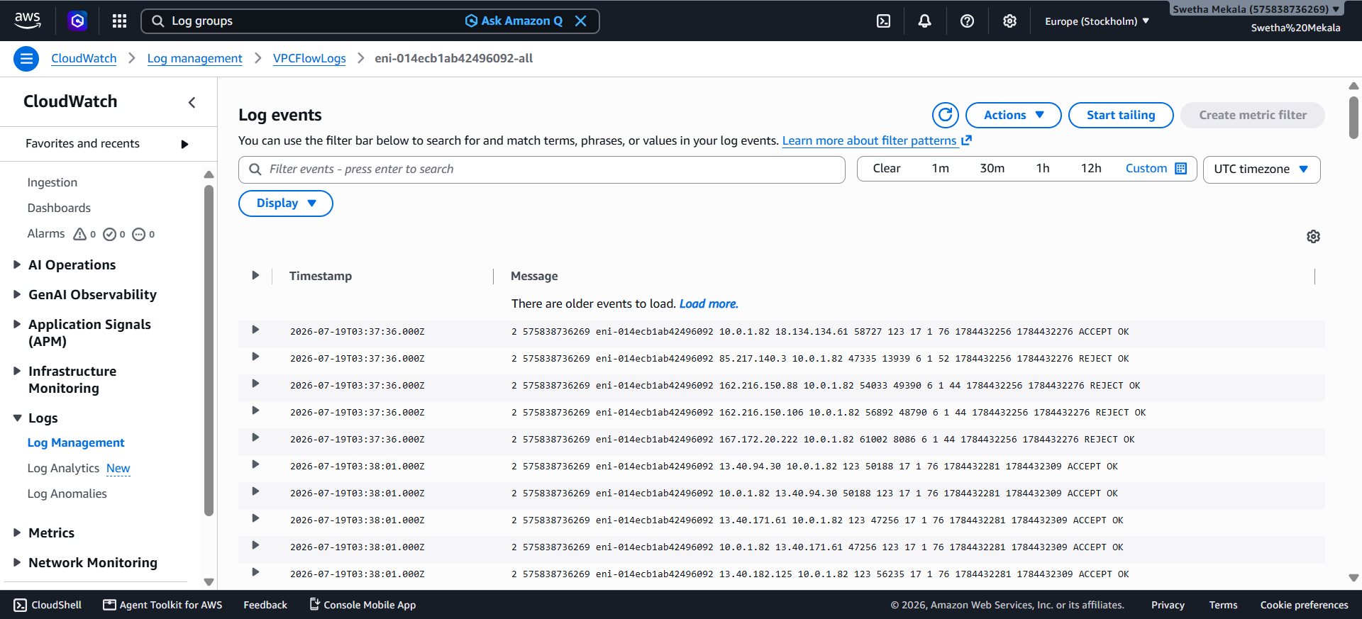
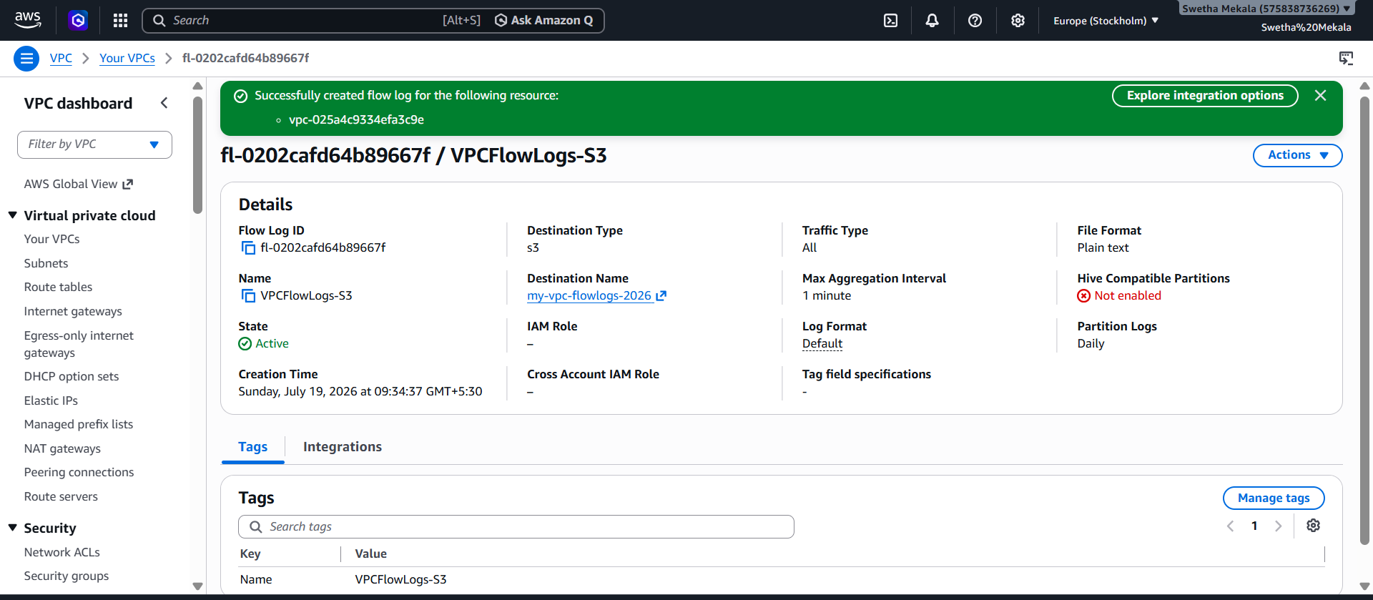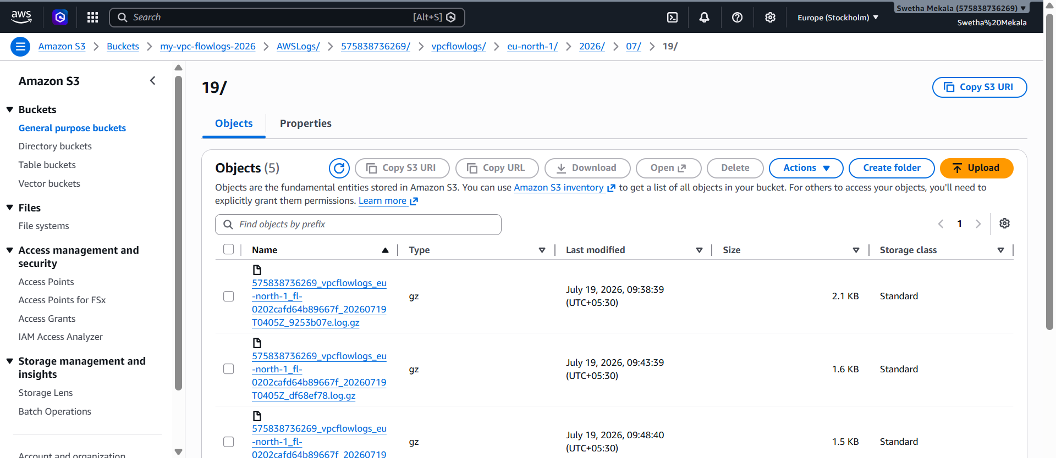
Commands Used
ssh -i ram_public.pem ec2-user@13.51.47.171
ping google.com

